Small SaaS CRM System

RevOps / CRM Operations Portfolio Project

Project Overview

Company Name
CloudNova

Industry
B2B SaaS

Product

CloudNova Project Suite

Business Model
Subscription-Based SaaS
B2B SaaS subscription software for remote project management.

Project Objectives
This CRM system was designed to:
- Organize customer and prospect data
- Manage the sales pipeline
- Track lifecycle stages
- Improve reporting visibility
- Automate operational workflows
- Standardize CRM data management

CRM Platform Used
Platform | Purpose
HubSpot | CRM operations and workflow management
Salesforce | Admin and automation practice
Google Sheets | Data cleanup and standardization

4. CRM Structure

Contacts
Purpose:
Track individual leads, prospects, and customers.
Tracked Fields:
- Name
- Email
- Phone
- Job Title
- Lifecycle Stage
- Lead Source

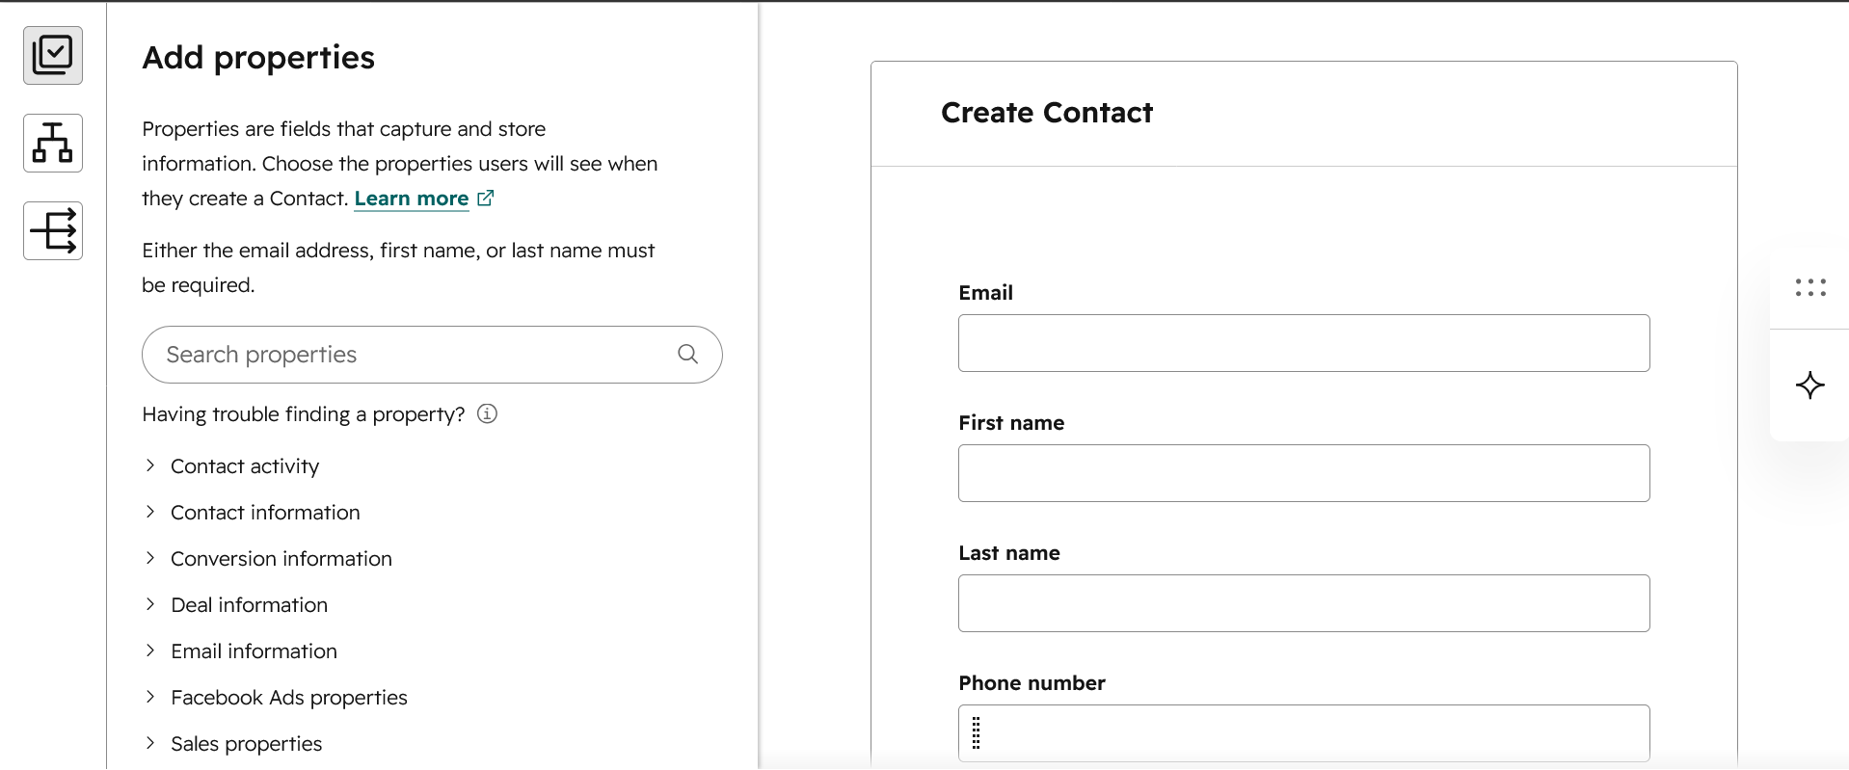
(Customized Create Contact form)
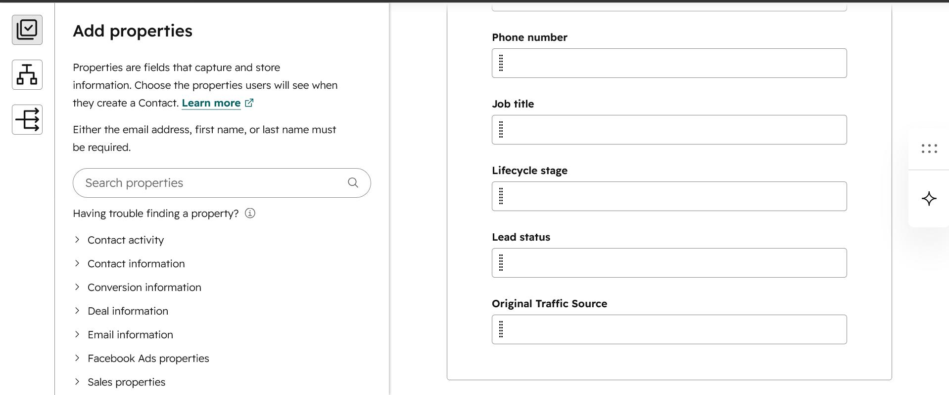
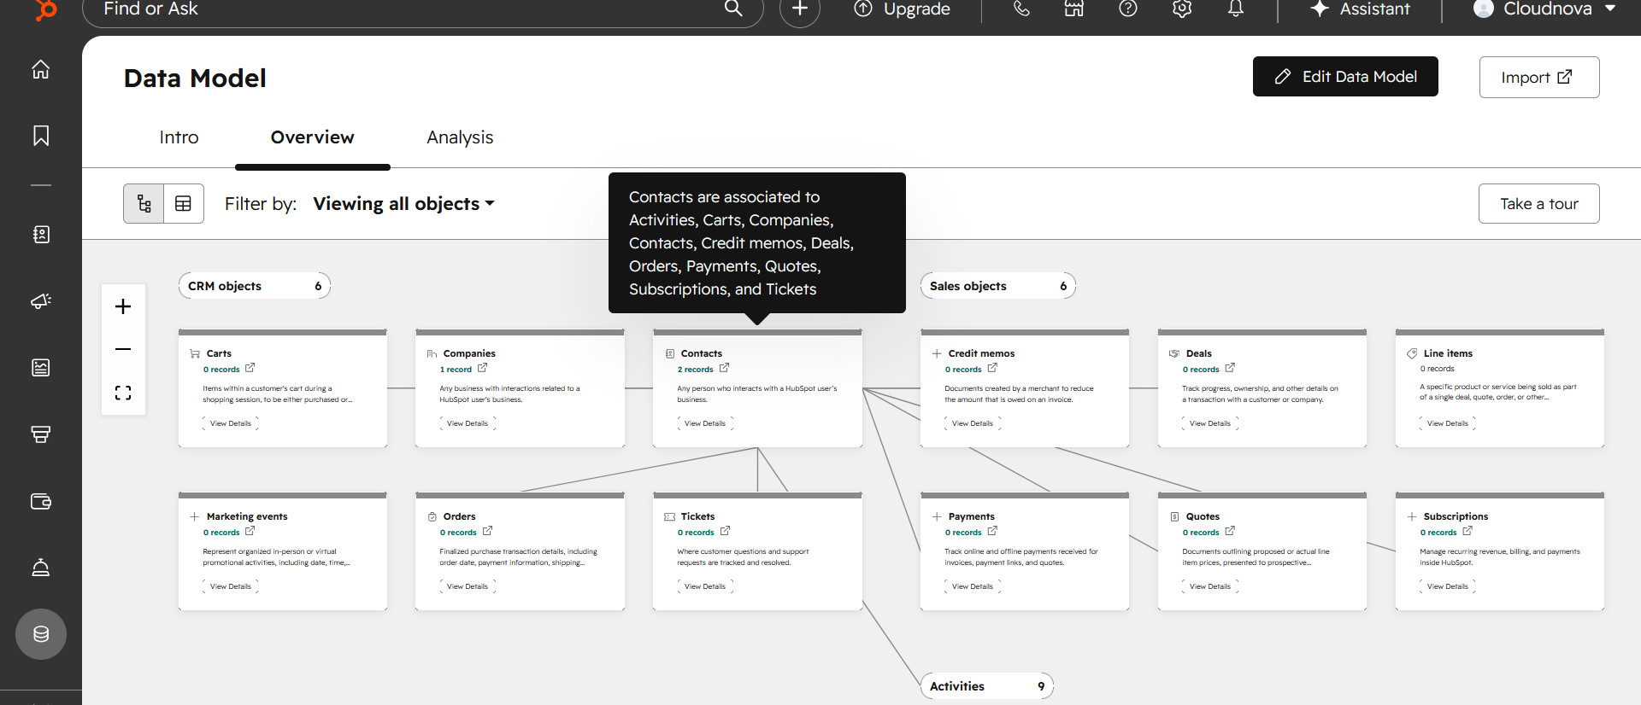
(Contact Lifycycle Stage/ Data Model)

Companies
Purpose:
Track business accounts associated with contacts and deals.
Tracked Fields:
- Company Name
- Industry
- Employee Count
- Revenue
- Website
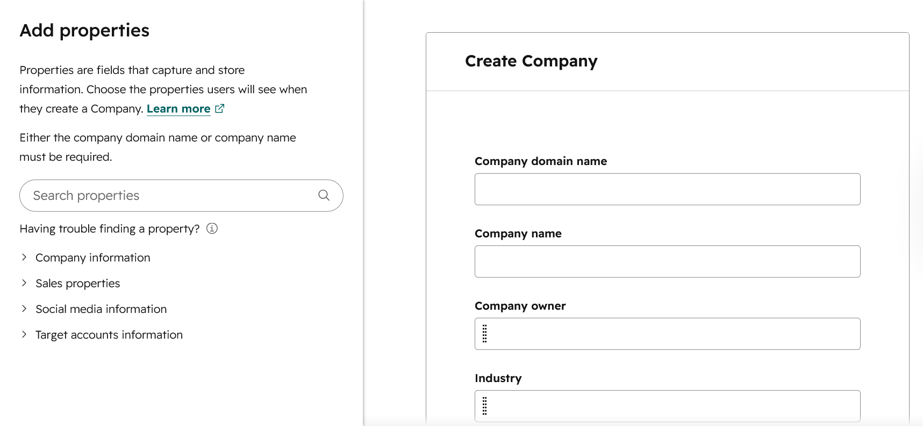
- Company Owner
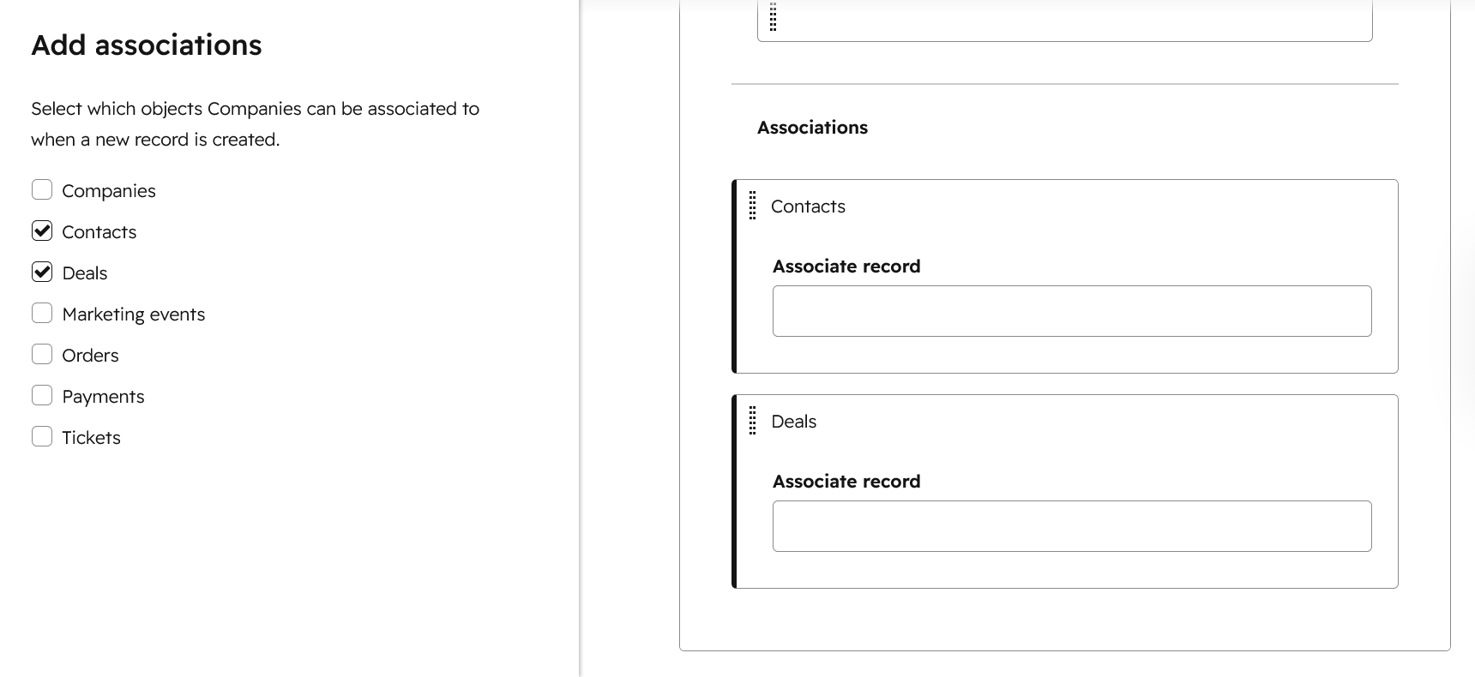
- (Company form/properties)
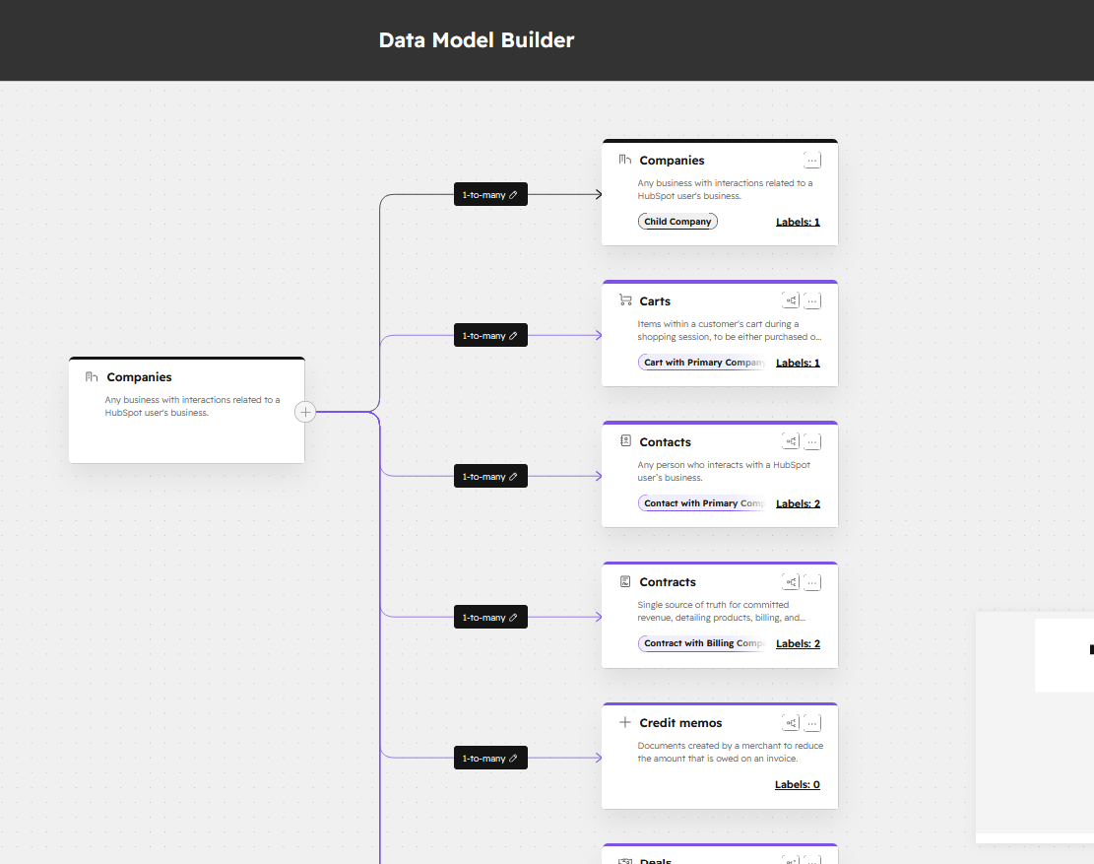
(Company Associations)

Deals
Purpose:
Track sales opportunities and revenue progression.
Tracked Fields:
- Deal Stage
- Deal Amount
- Close Date
- Pipeline
- Deal Owner

5. Lifecycle Stages
Lifecycle Stage | Purpose
Lead | Initial inquiry or engagement
MQL | Marketing-qualified lead
SQL | Sales-qualified lead
Opportunity | Active sales conversation
Customer | Closed-won client

Lifecycle Management Process

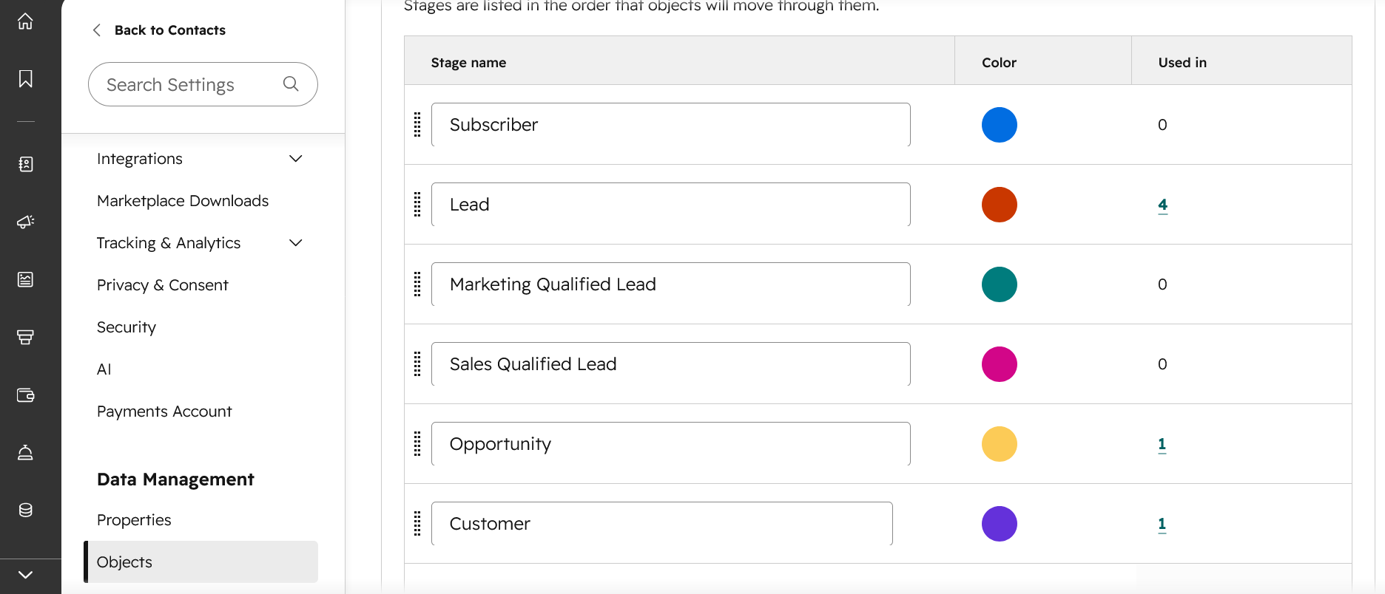

6. Sales Pipeline Structure
Deal Stage | Purpose
New Lead | Initial sales entry
Discovery | Qualification process
Demo Scheduled | Product demonstration
Proposal Sent | Pricing/proposal phase
Negotiation | Final contract discussion
Closed Won | Successful customer acquisition
Closed Lost | Lost opportunity

7. Workflow Automations

Workflow 1 — Lead Assignment

Trigger
When a new lead is created and the lead has a lifecycle stage of “Lead” or “Marketing Qualified Lead.”

Actions
Assign the lead to a sales representative based on territory, company size, or lead source.
Create a follow-up task for the assigned owner.
Set lead status to “New.”
Send an internal notification to the sales owner.

Business Purpose
This workflow ensures new leads are routed quickly to the correct sales owner, reducing response time and preventing leads from being missed. It supports cleaner lead management, stronger accountability, and faster sales follow-up.

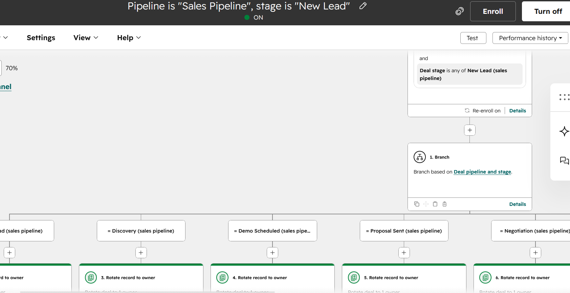
Evidence

Workflow 2 — Follow-Up Automation

Trigger
When a Subscription invoice is created

Actions
Create a record of the order.
Associate the order record with the related contact, company, and deal.
Update the customer’s lifecycle stage to “Customer” if payment or invoice status confirms an active subscription.
Create a task for the account owner to follow up with the customer.
Send an internal notification to the sales or customer success owner.

Business Purpose
This workflow keeps revenue and customer records organized after a subscription invoice is created. It helps the business track orders, connect billing activity to CRM records, and make sure customers receive timely follow-up after purchase.

Evidence
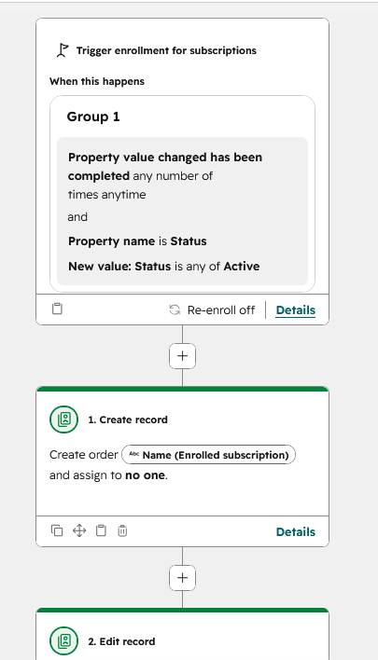
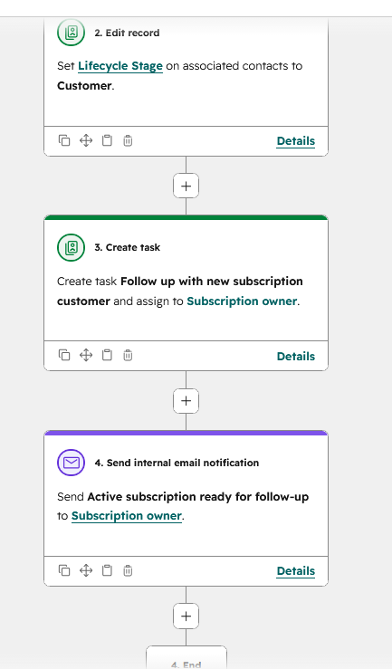

Workflow 3 — Customer Onboarding

Trigger
When a deal is marked “Closed Won” or when the customer lifecycle stage changes to “Customer.”

Actions
Create an onboarding task for the customer success owner.
Send a welcome email to the customer.
Create an onboarding ticket or project record.
Set onboarding status to “Not Started.”
Create follow-up tasks for kickoff, setup review, and first check-in.
Notify the customer success team.
With current limitations, a task-based onboarding workflow will be created.

Business Purpose
This workflow makes sure every new customer receives a structured onboarding process after becoming a customer. It reduces handoff gaps between sales and customer success, improves the customer experience, and helps the business track onboarding progress.

Evidence
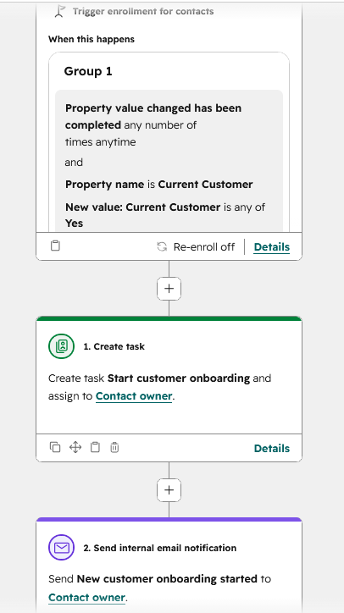
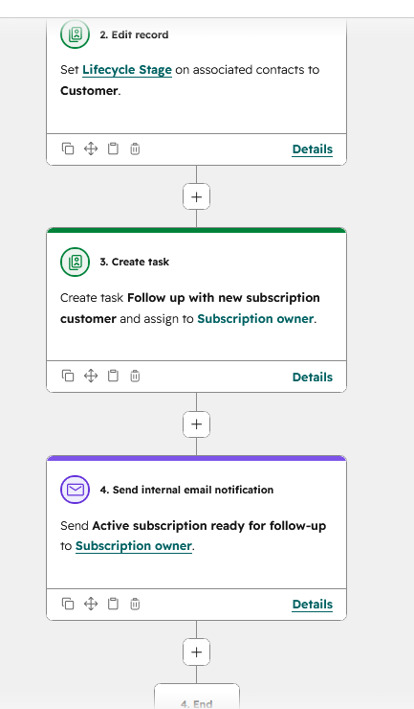

8. Reporting Dashboard

Dashboard Name
Revenue Operations Performance Dashboard

Reports Created
Report | Purpose
Deals by Stage | Pipeline visibility
Revenue Forecast | Forecasting
Deals Closed vs Goal | Sales performance
Activities by Rep | Productivity tracking
Lead Source Report | Acquisition analysis

Dashboard Summary
This dashboard provides a high-level view of sales and revenue performance across the CRM. The Deals by Stage report gives visibility into the current pipeline and helps identify where deals may be getting stuck. The Revenue Forecast report supports planning by estimating future revenue from active opportunities. The Deals Closed vs Goal report measures whether the sales team is on pace to meet revenue targets. The Activities by Rep report tracks productivity and helps managers understand rep engagement. The Lead Source Report shows which acquisition channels are generating leads, helping the business decide where to focus marketing and sales efforts.
Together, these reports help sales and revenue operations teams monitor pipeline health, forecast revenue, evaluate team performance, and improve lead generation strategy.

Evidence: (Next Page)

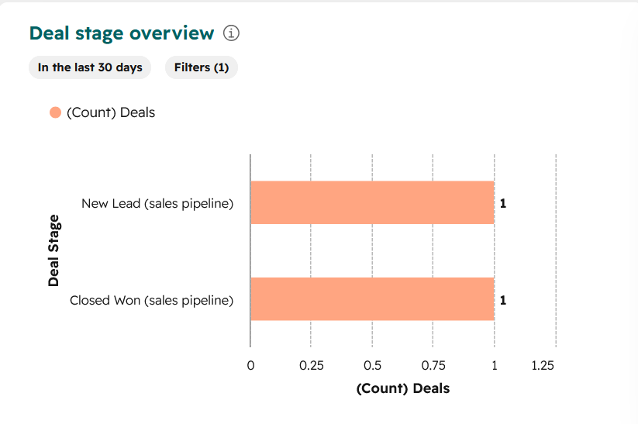
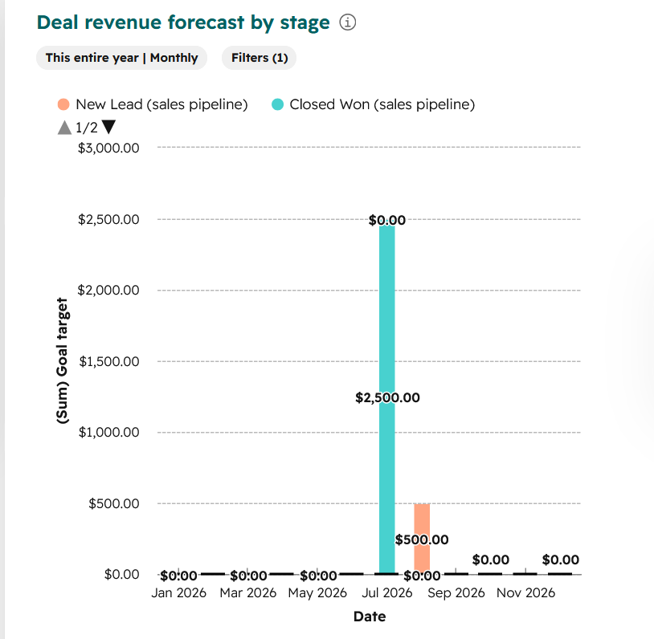
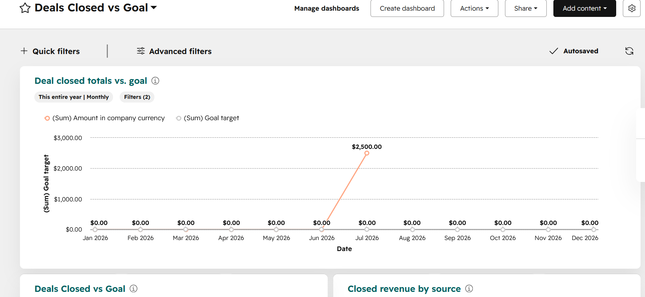
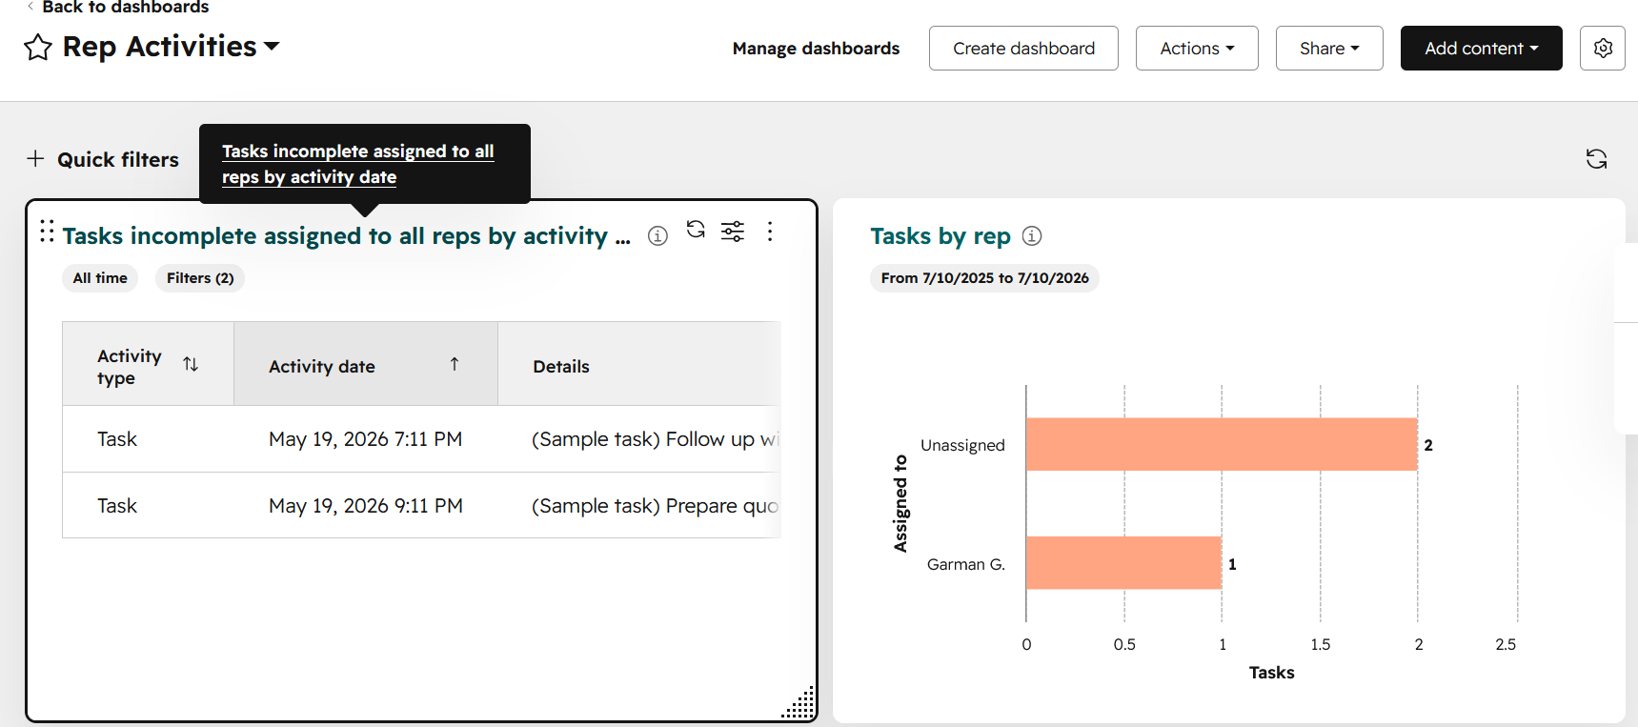

9. CRM Cleanup & Data Governance

Cleanup Standards
- Standardized capitalization
- Removed duplicate records
- Normalized phone numbers
- Validated required fields
- Corrected inconsistent formatting

Data Quality Process

CRM Data Reviewed: Completeness, accuracy, consistency, and duplicate records before being prepared for import or reporting. Records were first assessed for missing required fields, inconsistent capitalization, invalid formatting, and duplicate contacts or companies.
Standardizing: Names, job titles, company names, industries, states, and other text fields were standardized using consistent naming conventions. Phone numbers were normalized into a uniform format, while email addresses and required CRM fields were reviewed for completeness.
Deduplication: Duplicate records were identified using matching criteria such as email address, phone number, contact name, and company name. Potential duplicates were reviewed before records were merged or retained to prevent the loss of valid information.
Final Review: After cleaning, the data was validated to confirm that required fields were populated, formatting rules were followed, and records were ready for CRM import. Any information that could not be confidently verified was left blank or marked for further review rather than being assumed.

Evidence: (Next Page)

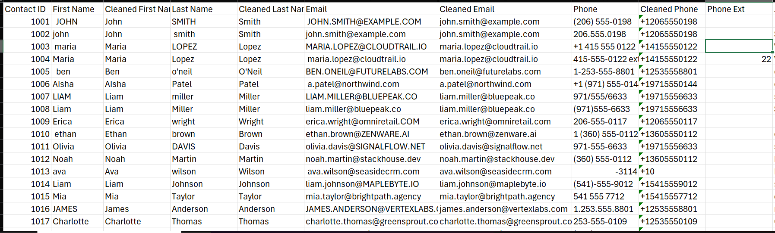
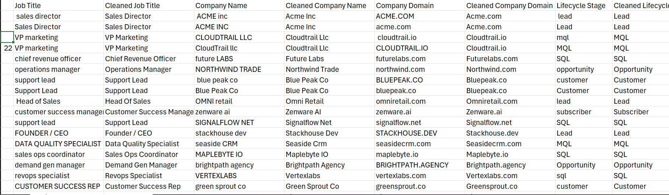
(Raw and Cleaned Data are put next to each other for easier comparison)

10. Key Metrics Tracked
Metric | Purpose
Win Rate | Sales effectiveness
Pipeline Value | Revenue visibility
Lead Conversion Rate | Funnel performance
Forecasted Revenue | Revenue planning
Deal Velocity | Pipeline speed

11. Problems Solved
Problem | Solution
Duplicate contacts | Deduplication workflow
Missing lead ownership | Automated assignment
Inconsistent lifecycle stages | Standardized definitions
Poor reporting visibility | Dashboard implementation

12. Skills Demonstrated
- CRM Administration
- Revenue Operations
- Pipeline Management
- Workflow Automation
- Data Cleanup & Standardization
- Reporting & Dashboarding
- Sales Operations
- Lifecycle Management

13. Final Project Summary
Designed and implemented a complete B2B SaaS CRM system in HubSpot to support the full customer lifecycle and sales process. The project included contact, company, and deal management; lifecycle-stage configuration; sales pipeline tracking; lead-source analysis; workflow automation; sales activity management; and dashboard reporting for pipeline visibility, forecasting, acquisition, productivity, and performance.
The CRM was also supported by data-governance standards covering duplicate management, required-field validation, capitalization, phone-number normalization, and consistent record formatting. Together, these components created a scalable and organized revenue operations system that improves data quality, strengthens reporting accuracy, and supports more efficient sales and customer-management processes.

Example:
Designed and implemented a complete B2B SaaS CRM system using HubSpot, including lifecycle management, sales pipeline tracking, workflow automation, dashboard reporting, and CRM data governance processes to support scalable revenue operations.

